Papers written by Australian Maths Software

SEMESTER ONE

MATHEMATICS METHODS

UNIT 3

2017

SOLUTIONS

SECTION ONE
1. (8 marks)
(a) (i) 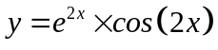
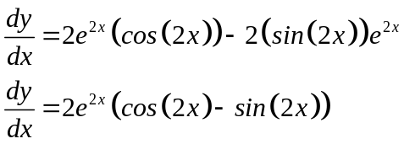
✓
✓ -1/error

(ii) 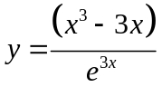
✓ ✓

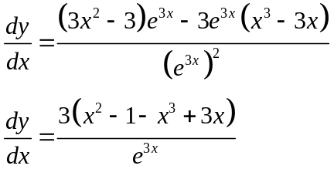
✓

(b) 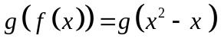
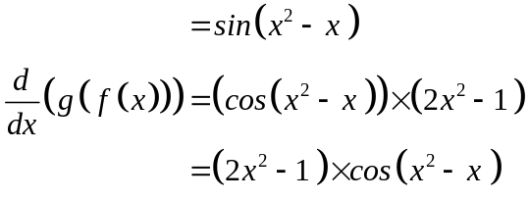
✓✓
✓
.

2. (9 marks)
(a) 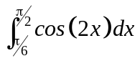
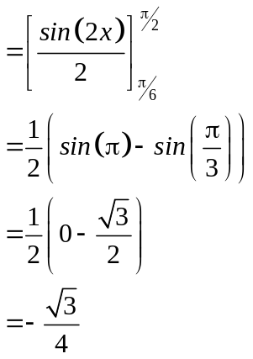
✓
✓
✓

(b) 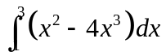
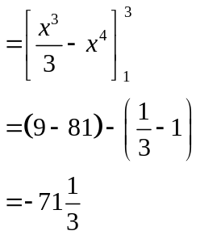
✓
✓

(c) 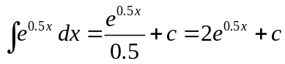
✓
(d) 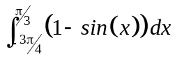
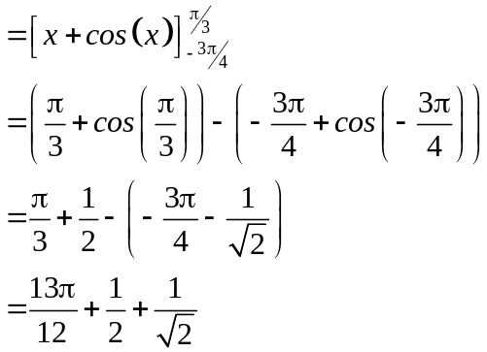
✓
✓
✓

3. (7 marks)
(a) (i)
 | 10 | 11 | 12
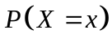 | 0.36 | 0.36 | 0.28
✓✓

(ii) 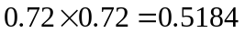
✓ ✓

(b) (i) Can represent a probability density function as the probabilities add to
one. ✓

(ii) Cannot represent a probability density function as the probabilities add
to 1.1 ✓
(iii) Cannot represent a probability density function as one of the probabilities is negative. ✓

4. (6 marks)
(a) 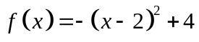
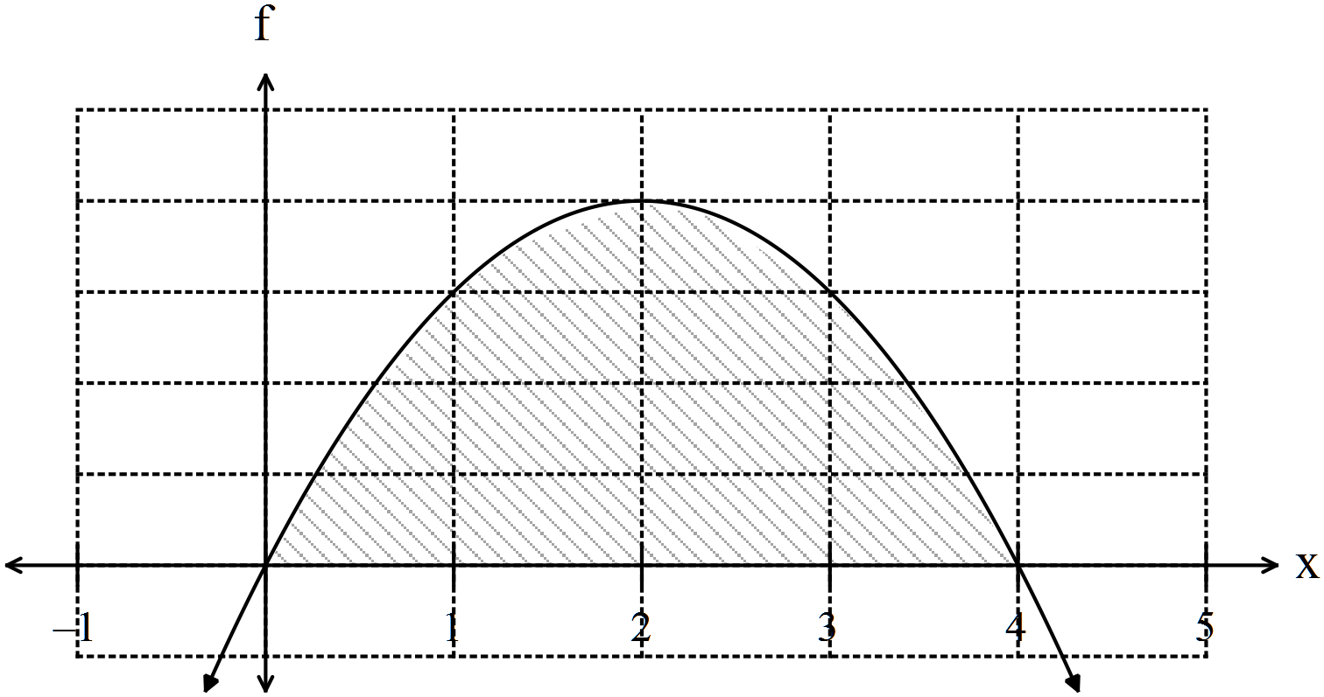
✓
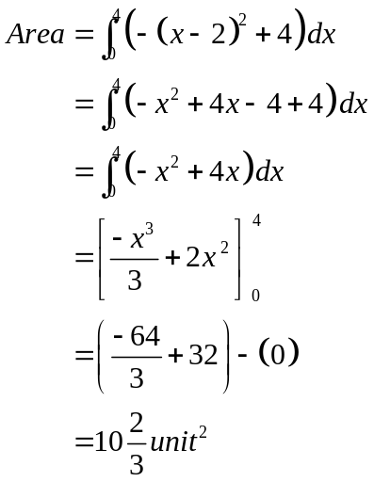
✓
✓
(b) 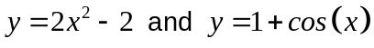
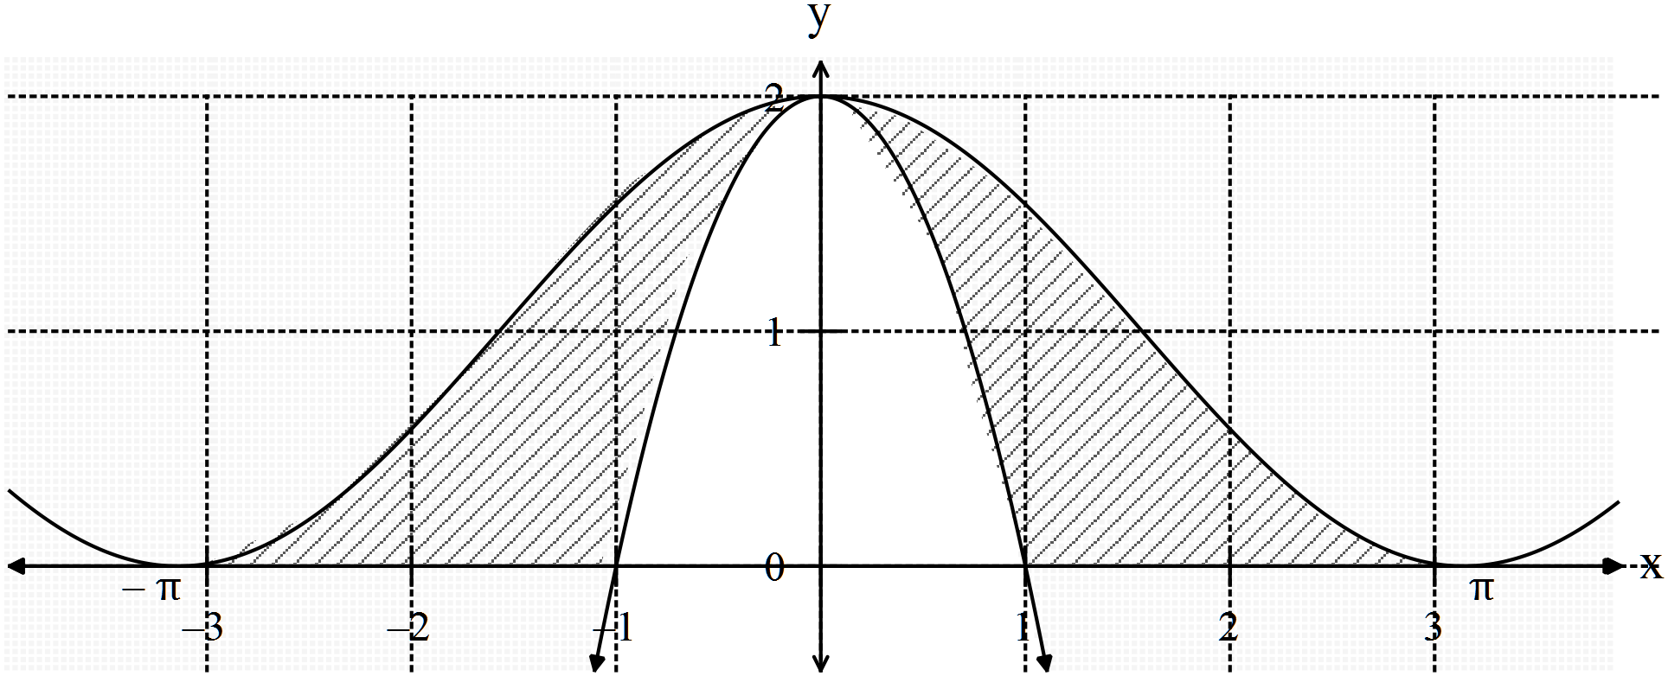

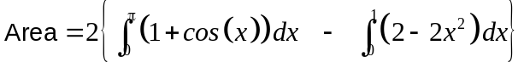
✓
✓
✓
5. (9 marks)
(a) 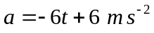
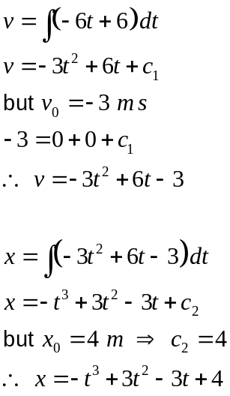
✓
✓
✓
✓

(b) At 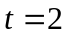
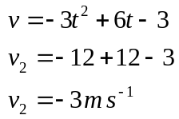
✓

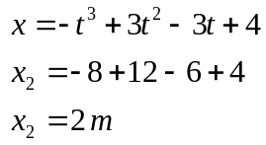
✓

(c) Particle changes direction when the velocity is equal to 0 m s⁻¹.
✓
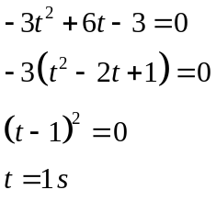
✓
✓

6. (7 marks)
(a) 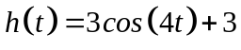 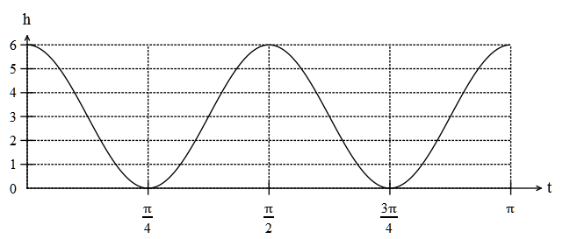
✓✓ -1/error
(b)
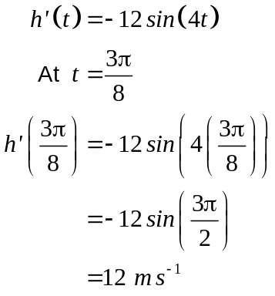
✓
✓
The piston is rising at 12 m s⁻¹.

(c) 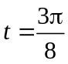 is exactly between 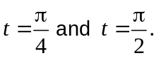 This is at the point of inflection
✓
where the gradient is at its highest as it has been increasing from zero at 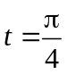
at the minimum turning point and starts to decrease after . This means the
✓
rate of rise of the of the piston is greatest at .
✓
(d) 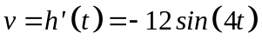
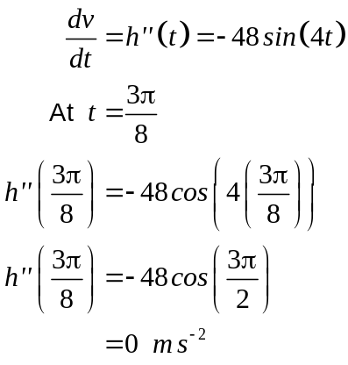
✓
✓
✓
So at 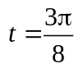 the rate the velocity of the piston is changing at 0 m s⁻².

7. (4 marks)

Show that 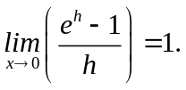
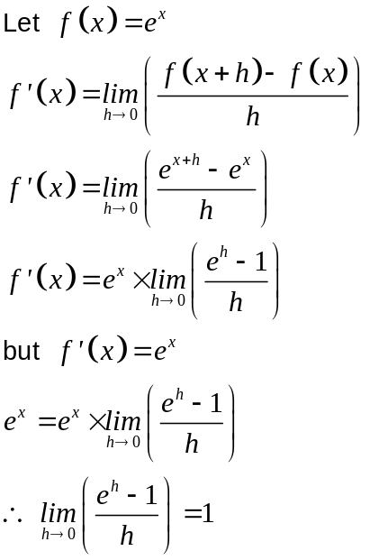
✓
✓
✓

END OF SECTION ONE
SECTION TWO
8. (7 marks)
(a) (i)
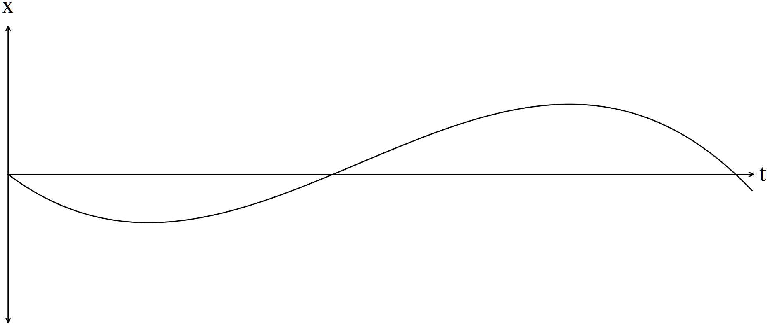
✓✓

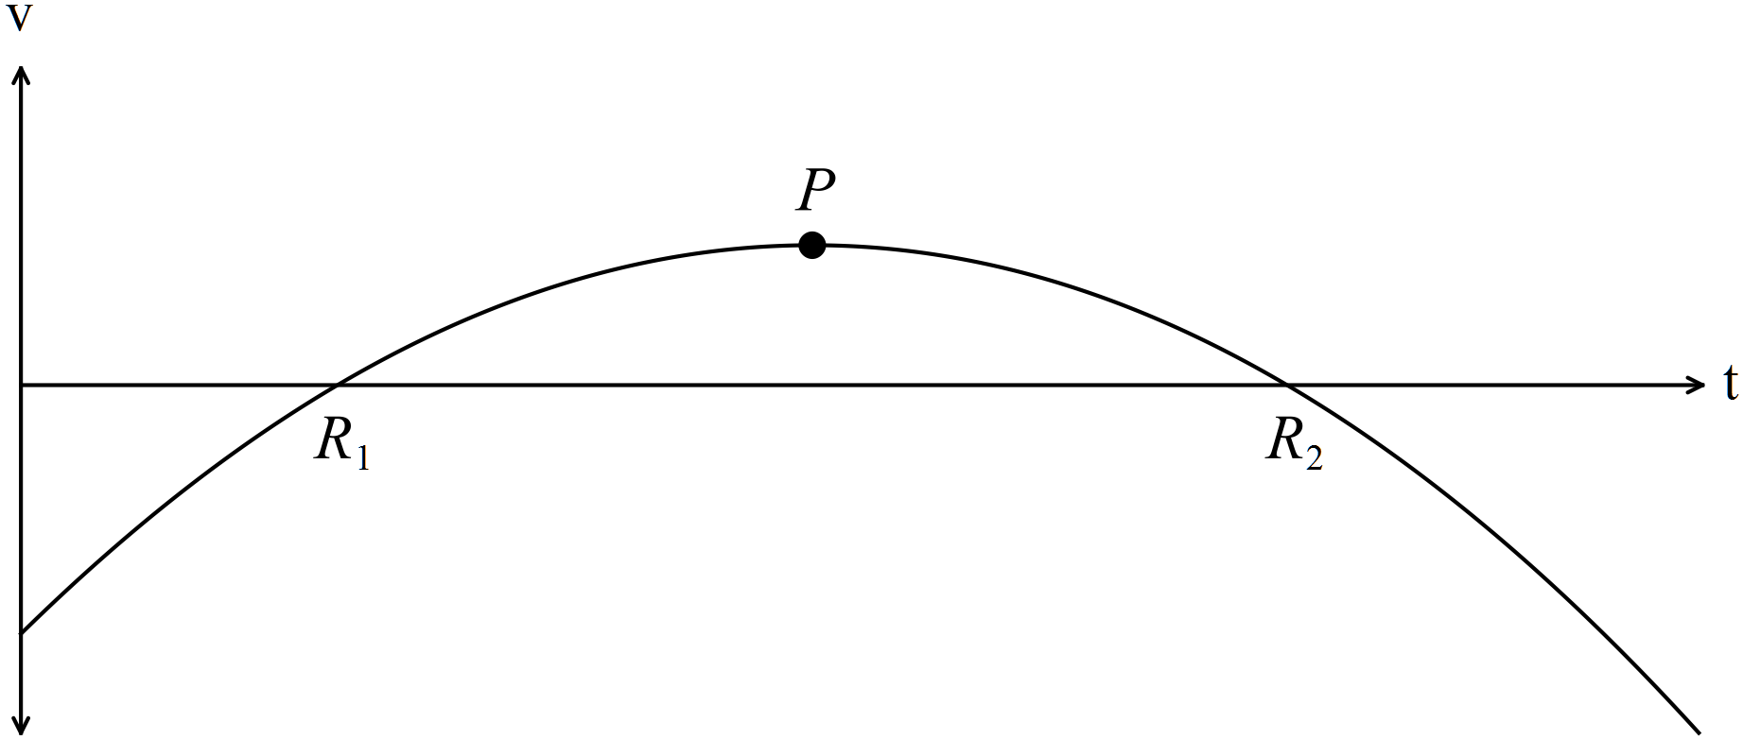
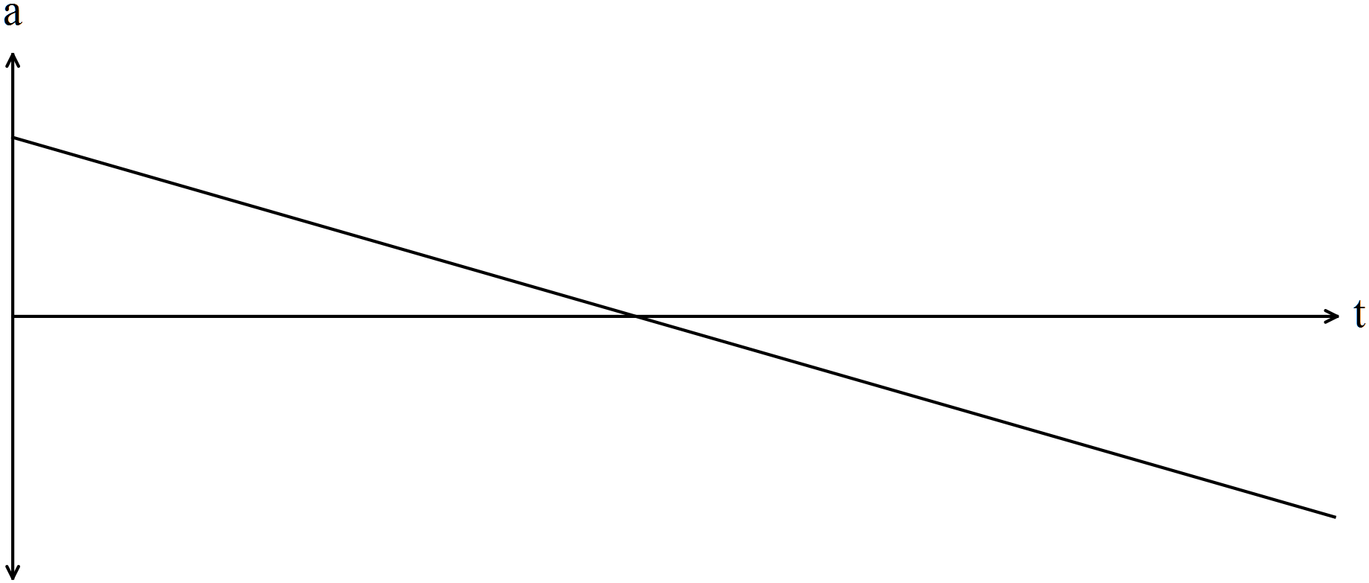
✓✓

(b) The roots of 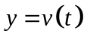occur at the same t value as the turning points on 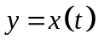.
✓
At 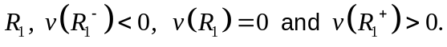 , i.e. the turning point in
is a minimum.
At 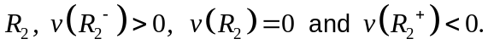 , i.e. the turning point in
✓
is a maximum.

The turning point of , P, has a zero gradient so its derivative, 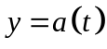
has a zero value at 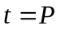.
The gradient of is positive for 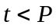and is negative for 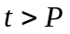, so the
✓
linear function is a decreasing value with an x intercept at .

9. (6 marks)
(a) (i) 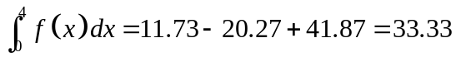
✓

✓

(ii) 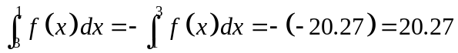
✓

(iii) 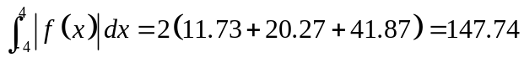
✓ ✓

(b) 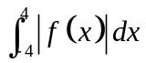
✓

10. (6 marks)
(a) 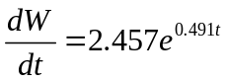
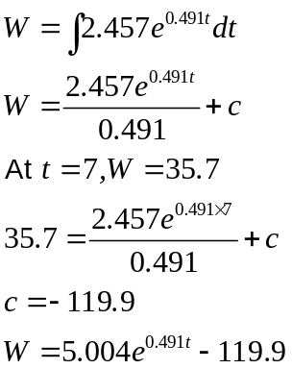
✓
✓
✓
(b) 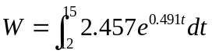
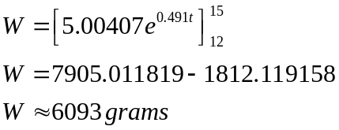
✓
✓
✓

The expected total change in the weight of a halibut between 12 and 15 months
old is 6093 grams.

11. (11 marks)
(a) 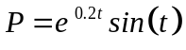
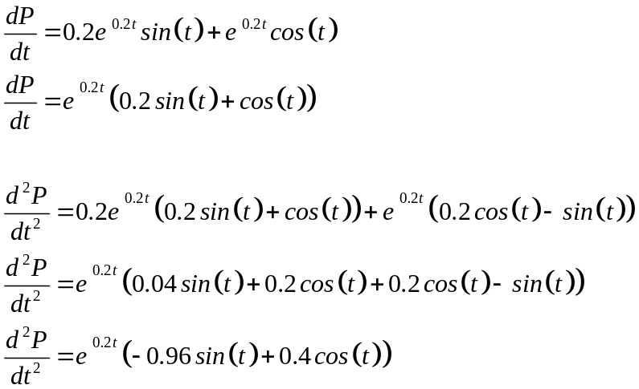
✓ ✓

✓ ✓

Find where 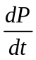= 0 to find the turning points then use 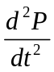 to identify the types of turning points.
If < 0 then maximum turning point. If > 0 then minimum turning point.
If = 0 then you have the t value so you can find the points of inflection. ✓✓
(b)
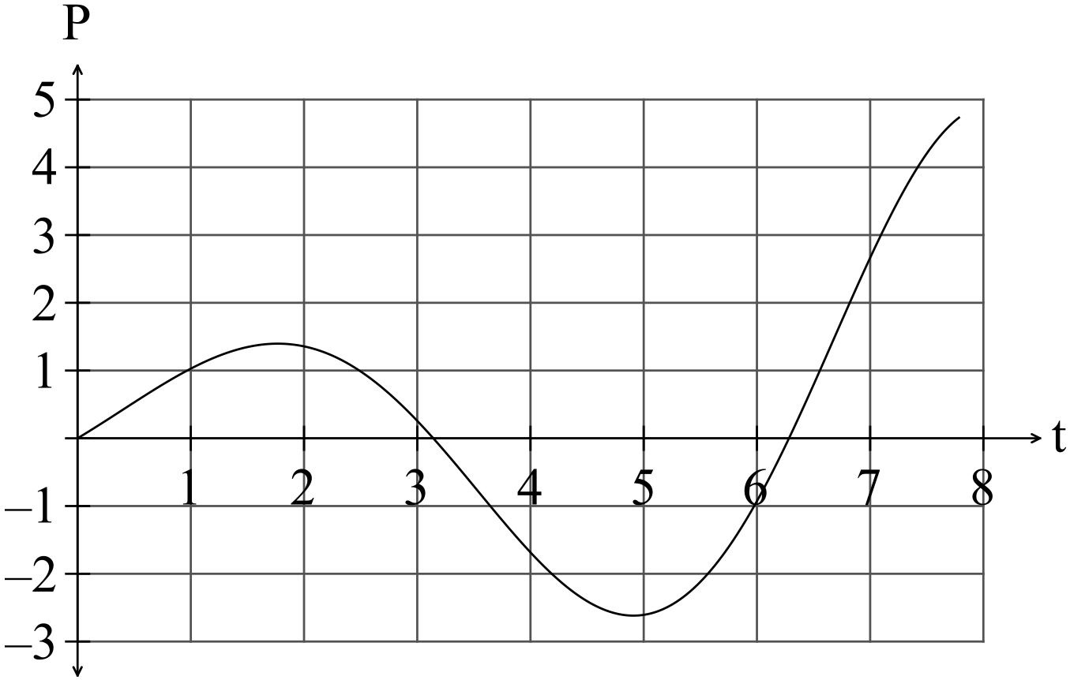 ✓✓✓ -1/error
(c) The profit started to increase again at 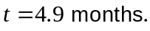 ✓

(d) The break even point was reached at 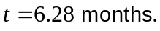 ✓

12. (10 marks)
(a) (i) 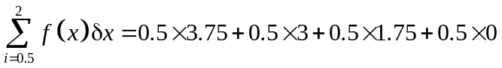 ✓✓
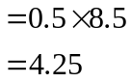
✓

(ii) 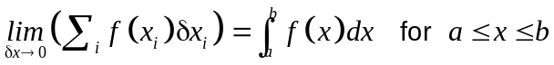 ✓✓

(b) (i) 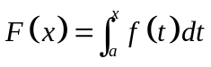
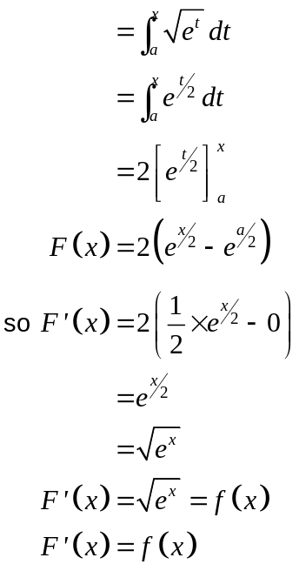
✓
✓
✓
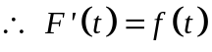

(ii) 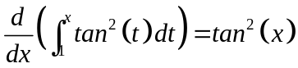 ✓✓

13. (5 marks)
(a) 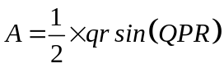
✓
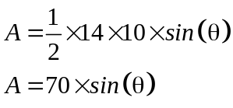
✓

(b) 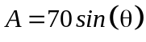
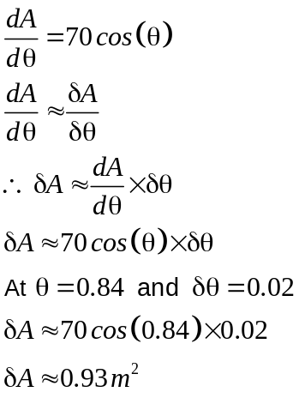
✓
✓
✓

14. (7 marks)
(a) 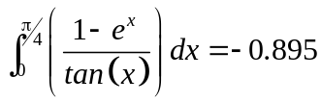 ✓✓✓ (3 decimal places)
(b) 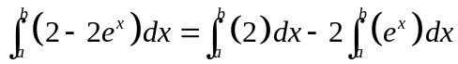
✓
✓
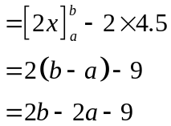
✓

(c) 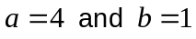 ✓✓
15. (8 marks)
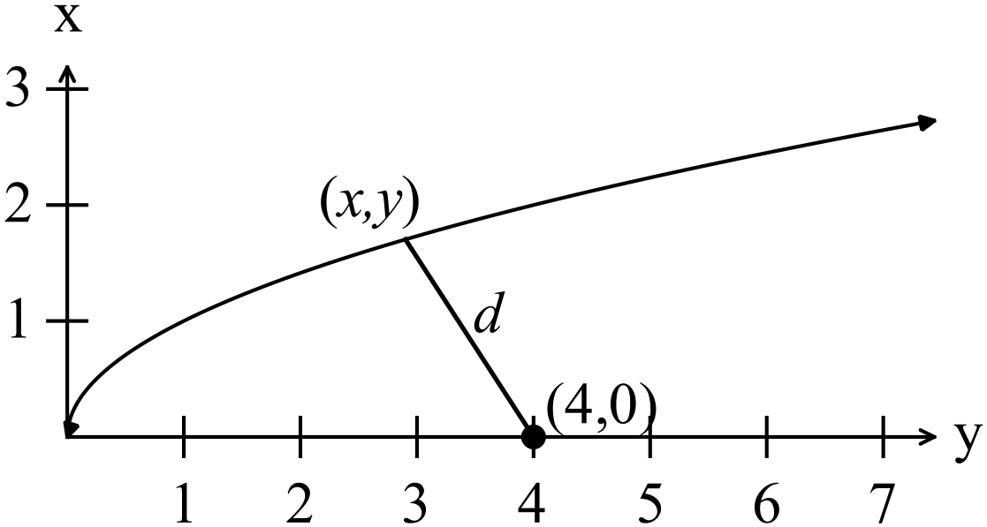

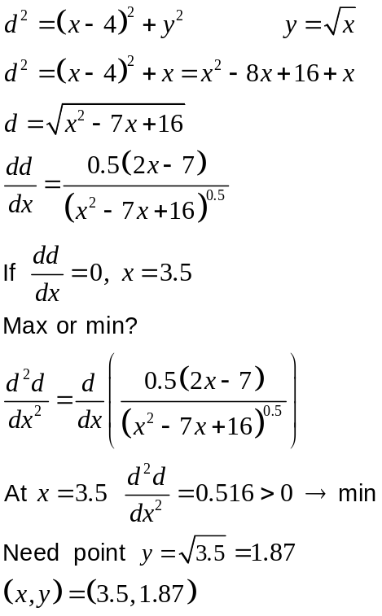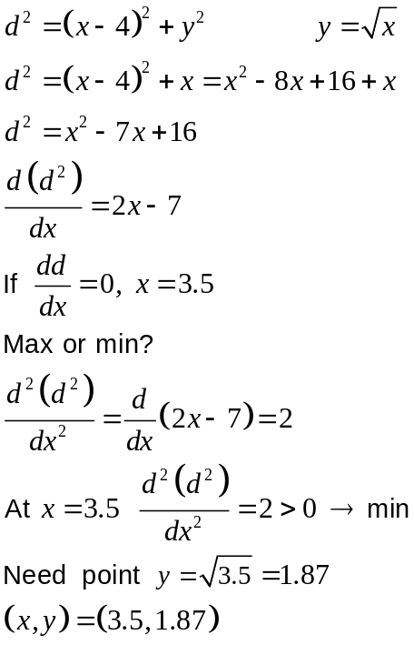
✓
✓
✓
✓
✓
✓
✓
✓
OR

16. (5 marks)
(a) 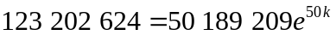
✓
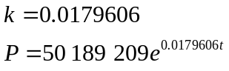
✓

(b) 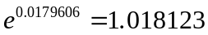
✓
The annual rate of growth of the population is 1.8123%
(c) 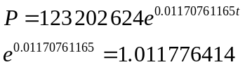
The annual rate of growth of the population is now 1.1776414% so the rate of growth of the population has slowed down considerably.
✓

(d) 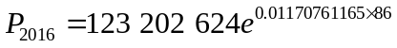
✓
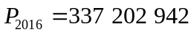

17. (4 marks)
(a) 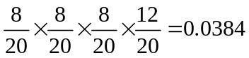
✓
✓

✓
(b) 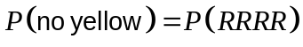
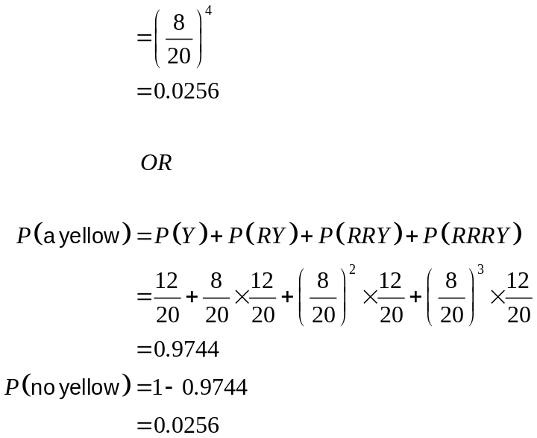
✓

18. (5 marks)
(a)
x | 0 | 1 | 2 | 3 | 4 | 5
P(X = x) | 0.17 | 0.36 | 0.31 | 0.13 | 0.03 | 0.00

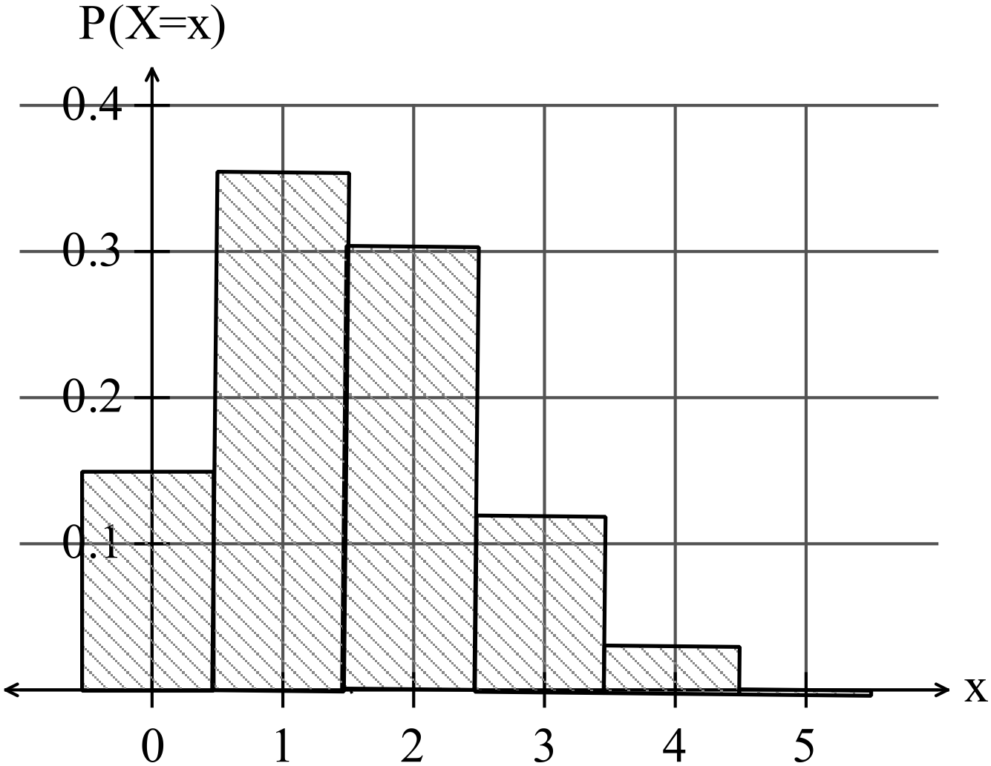
✓✓✓✓ -1/error

(b) p = 0.7

19. (10 marks)
(a) (i)
x | 1 | 2 | 3 | 4
P(X = x) | 0.3 | 0.2 | 0.2 | 0.3

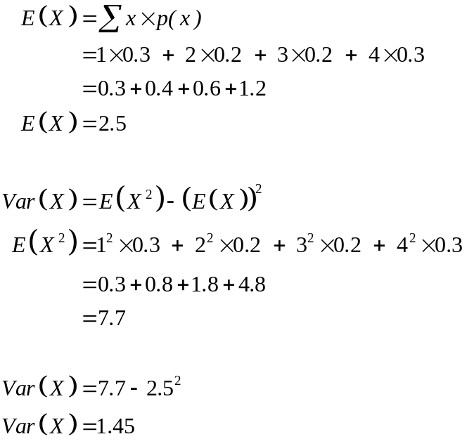
✓✓
✓
✓
✓
✓

(ii) 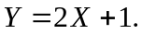
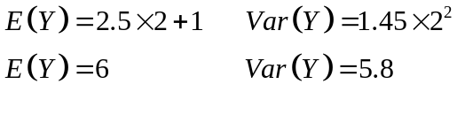
✓
✓

(b) Sam’s average payout
✓ ✓

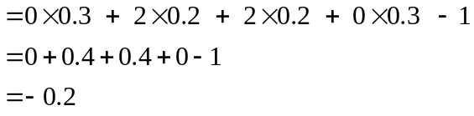
✓
Sam loses an average of 20 cents per spin.
20. (14 marks)

(a) 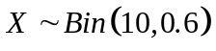
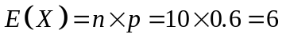 ✓

(b) 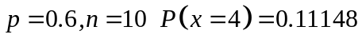 ✓✓

(c) 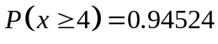 ✓✓

(d) 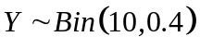
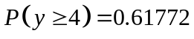 ✓✓
✓
✓
(e)
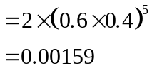
✓

(f) 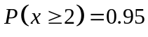
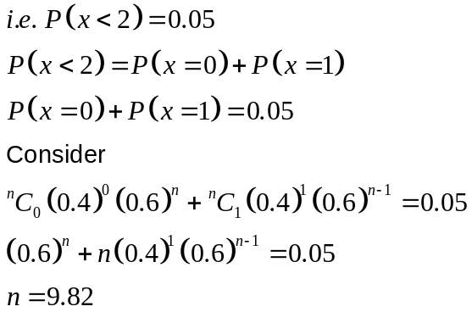
✓
✓
✓
Ten (or more) seedlings must be planted to have a 95% chance of obtaining at least two white flowering plants.
✓

END OF SECTION TWO

